Holistic Ministry in the
Urban Slum Community:
Creating Upcoming Entrepreneurs
From India’s Youth
By: Heidi Rico
The Organization’s Introduction
My colleague, Sean Magaña, and I have been working this semester with the NGO called Mission to the Unreached (MTU). Here is some information about the organization that will provide an overall foundation and idea of their principles found within their holistic ministry:
“Mission to the Unreached is a
National indigenous nonprofit organization committed for holistic development of the people of India. Mission to the Unreached is committed to holistic development of the people of India. It is focused on urban slums, resettlement colonies, villages, and rural areas.”
- MTU Website
MTU’s vision is to be able to reach out to the communities of underprivileged people. Their motto is “born to serve others.” This model to standby encourages cooperative interactions and relationship building within the community.
The NGO has been practicing, for over 25 years, holistic ministry through many different avenues. They have demonstrated this through their diverse activities and programs, which will be discussed later. The organization’s mission strives to specifically support women and children. They provide opportunity for women to enhance their job skills, in order to help uplift their families and statuses within the community. Their holistic model aims to help slum communities through “social, economical, cultural, and intellectual development.”
Entrepreneurial Programs
According to Greer & Smith (2009) microfinance is not solely based on assisting the poor through the means of production. There is a challenge that involves building entrepreneurial skills among underserved groups, such as beggars, prostitutes, and children. MTU participates with the community in many ways. The organization provides rehabilitation for widows, deprived woman, un-employees, and elderly. Income generated or social entrepreneurship programs include: tailoring classes, toy-making training, beautician courses, computer education, arts & craft training, fabric painting training, and leadership training. There is a wide array of options, in order to meet the needs of different members of the community. This speaks to the organization seeing people uniquely made in the image of God and catering to that specificity by offering trainings in different subjects area. Those in disadvantaged statuses, in society, are able to be uplifted through entrepreneurship when they are given new job opportunities. Looking to constantly mobilize and uplift their surrounding communities, MTU creates opportunities for income generation for young and old alike, through their various programs.

The History of Failure
When meeting with the Founder of MTU, Pastor Varghese Thomas, bluntly came to terms about microfinance programs within the organization. He said they did not work in India. He said they tried running them in MTU and they failed. This was not a surrender to the subject or a close to a discussion for future growth. It was the opening of a door; a knock for opportunity. It was a simple and honest reflection of their reality and he was open to new ideas that would best serve the community. What the organization does with their failures is acknowledge them and put them on the table to sort out where the potential for growth could be. There is transparency. Transparency in the light of India provides transformation.
You build on failure. You use it as a stepping-stone. Close the door on the past. You don't try to forget the mistakes, but you don't dwell on it. You don't let it have any of your energy, or any of your time, or any of your space.
- Johnny Cash

Read more at http://www.brainyquote.com/quotes/keywords/door.html#GmWwlv2EXsT3LKE3.99
While assessing poor communities, Schreiner (2008) presents information that I felt conflicts with the context of India. “Transparency and simplicity builds trust.” (2) In the Indian context, I consider two conditions that I believe India struggles most with: transparency & trust. The political leaders of the nation are known for their corrupt ways. They justify their actions through karma. This never-ending religious cycle creates a perpetual state of evil vindicated. How can a country build trust when its members of society know their leaders are people not to be trusted? In that corruptness, how is there supposed to be transparency amongst the evil doings?
The truth that surfaces as a result of trust and transparency is that organizations, like MTU, bring about good and are able to engage successfully with the community because of the presence of transparency and simplicity. This opens doorways for transformation because community members are able to build a sense of trust.
Greer & Smith (2009) state, “From a spiritual viewpoint, there is a critical need for further training of pastoral staff to teach congregations how to responsibly handle increasing financial resources and how to live out the gospel in every area of their lives.” Where the organization felt they were failing to meet the needs of the community is where we came into the picture. This is where the need for economic development needed to occur. Our curriculum looked to foster the practicality of economic discipleship and compliment it to the organization’s firm foundation in holistic ministry. To me, this is an organization that seeks innovation, encourages creativity, and as a result will produce change. They are looking to fulfill the spiritual viewpoint of helping community members live out the gospel on a daily basis.
Educational Resources
Adjacent to the main office of MTU is the Education Development Center (EDC). This is the slum school sponsored by MTU, serving about 350 children, standards 1-12. New Ashok Nagar is the location of our internship and has been the source of where relationships have been built with the students, families, and staff. What the school has modeled to us has allowed for us to build stronger relationships with the community. Our supervisor, Arun Kumar Sonar, Project Coordinator with Mission to the Unreached, has demonstrated an intimate understanding of whom he serves. He takes time to sit, listen, and to problem solve with community members. He seeks the best to understand not only the particular setting, but also the family as a whole so that he may gain a greater perspective for the situation(s) at hand. Greer & Smith (2009) discuss that part of good microfinance is building the youth through microfinance initiatives. This includes providing a variety of opportunity for training, nurturing, and income generation. According to research, out of Youthworks, one hundred percent of microfinance loans issued to young adults have been fully repaid. This refutes the notion of the youth being irresponsible and unreliable. (135) The youth needs empowerment, encouragement, and trust to help build strong communities. The EDC has served as a safe house for children, by providing meals, education, and training in job-related skills. The investment they choose to put into the youth of India is demonstrated through their relationships, activities, and opportunities for growth that they share with families.
The Ultimate Curriculum Goal
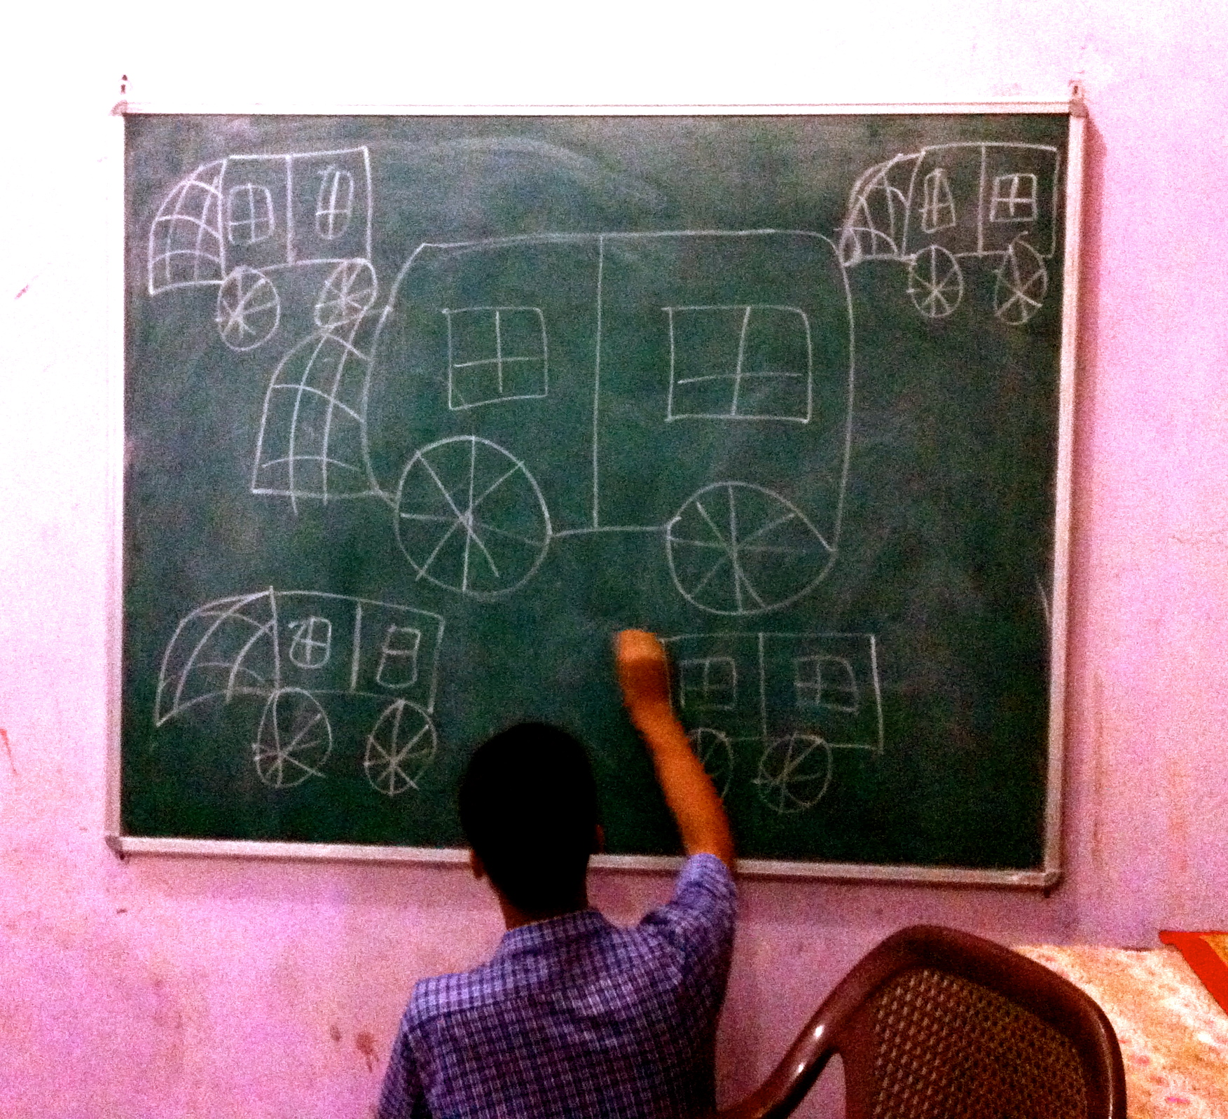
Pastor Thomas encouraged us to build a program that developed an understanding of economics in a holistic model. He was open to any new curriculum we were willing to develop. We agreed that we would build 10 lessons for students and parents who attended the CDC. This information was based out of Grigg’s (2010) economic discipleship themes. Our model was made to encourage upward mobility in the slum community. From the pastoral staff of MTU, there was an insider perspective that there needed to be stimulation and education in the economic field. Hence, to build a curriculum, using biblical principles, students would be able to use that knowledge to further themselves, their family, and their community. This matched the mission of the organization and what we were looking to do within the community. This would help build up the organization’s failures into successes.
Students learning and engaging with the concept of quantity versus quality, through the use of drawing auto rickshaws.
Meeting the Contextual Need(s)
Over the course of the classes, we worked with students using biblical principles that would consistently encourage applying practicality to the concepts of creation, the laws, and redemption. To help match the community resources available, we made materials for lessons simple and easy to obtain. Using cooperative learning to gain economic understanding, we wanted to engage with students in a way that would encourage the opportunity for financial help in their future. Our curriculum provides a stepping-stone to gaining self worth, understanding for the need of cooperation, and learning how to visualize your self in the world as an agent of change. This course looks for transformation through the integration of understanding and practice. The populations we have been working with are teenagers, standards 8-12, and parents. We work with teenagers twice a week for a total of four hours. With the parents, we work with them every other week for about an hour. The course curriculum consistently requires reflection of how you affect yourself, your family, and your community.
In order to best meet the needs of the students, Sean and I created a video that illustrated the adapted story from the scriptures. We had been telling the students a condensed adaptation of the creation story, jubilee, death, resurrection & redemption, for every class. We worked with our students, in class, to develop our video in order to reflect an accurate, cultural understanding. From cognition to verbalization, we put the students visualizations to paper through the use of an art activity. We wanted to use pictures that were contextual and spoke to our age group, appropriately. For an activity, we asked the students to illustrate what they pictured, as we verbally told the story. Students drew Adam and Eve with their natural surroundings of peepal & coconut trees, camels, and monkeys. It was truly an Indian perspective of our compilation. Some student even labeled parts of the story in Hindi script. It was engaging and encouraging going back and translating the story in Hindi and matching the concepts with the children’s perspectives in mind. It gave deeper appreciation and meaning to our work. We knew the importance of contextual understanding and reflection in our curriculum. Hence, through all of our activities, we had every intention of letting the curriculum speak specifically to our people group. 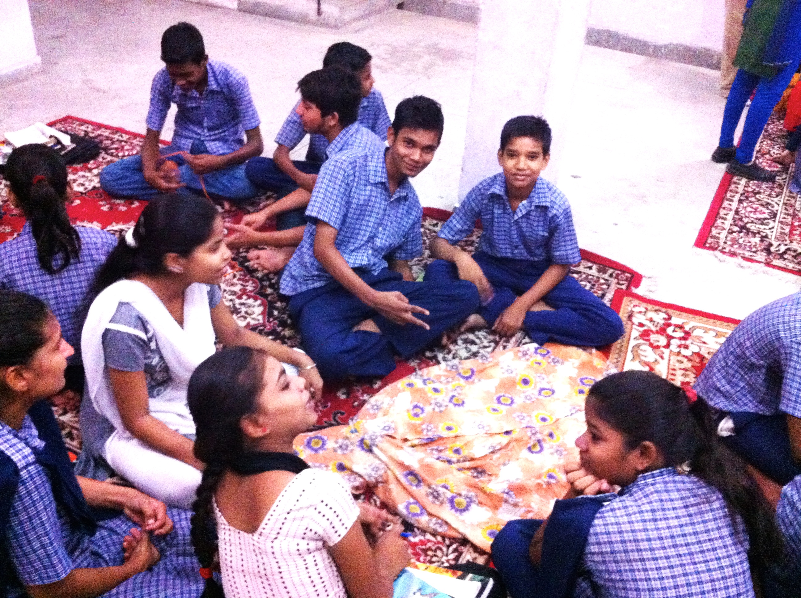
Establishing the Entrepreneurial Spirit
Greer and Smith (2009) discuss that in order to “unlock entrepreneurship” we must build a vision for the future. This involves building knowledge of loans & savings and how to establish a timeline for future reference. We offer this stepping-stone through exercises that establish a sense of budgeting skills and record keeping. This helps community members see more of a long-term perspective to their finances. From our experience in our teachings, the mindset of India, particularly in the slum communities, is a “today” mentality. (85) Parents in our adult class were asked if they know what a budget was and/or used one at home, during our Management, Savings, and Debt class. One woman raised her hand and said she keeps one with her husband. The rest not only did not have a budget, but also had no concept of what a budget was. The idea of keeping track of expenses past a twenty-four-hour-period seemed foreign.
Students develop inventions from everyday household products to help gain perspective to the biblical theme of ‘creativity’.
What we found was that parents needed to gain skills of tracking their expenses to be able to begin saving money. We were able to connect the concept that making efforts to create cash flows and record keeping helped gain a better image of what your family can and cannot save for. We connected back to the theme that when you make the effort to save, you made the effort to support your family in the long run by educating your children. We found collectively that parents wanted the best for their children and that involved a better life than what they were living. We used their previous answers to promote understanding and reasoning for creating a budget.
Bhatan (2012) discusses India’s mode of servility. “At school, our education system hammers out our individual voices and kills our natural creativity, turning us into servile, course-material slaves. Our kids are not encouraged to raise voices in class, particularly if they disagree with the teacher. And of course, no subject teaches us imagination, creativity, or innovation.” (21) Let us pull out the key biblical principles India’s school systems are intentionally destroying: creativity & productivity. How can students with a stunted creativity, be expected to produce anything good?
In our curriculum, we aimed at fostering what the culture appeared a need for nourishment in. Pastor Thomas claimed that micro financing failed within their NGO, so we helped establish an understanding of economic development, within the youth, so that finance concepts could be solidified early on. By providing the students with cooperative learning opportunities, this shifted focus from the teacher as the power keeper, to granting power to the students. Now at first, this was a complete failure. This is because of the fact that the children had never been given the opportunity to put their thoughts on the table. Part of the entrepreneurial mind is having the ability to create and innovate. Our curriculum sets up a learning environment that encourages this type of thinking for not only the classroom environment, but within their family and their community. This includes the work (for future prospect), school, and home environment.
Growth Over the Course
When speaking to the students, toward the end of our coursework, we interviewed them on the subject of careers, because we knew they would be able to reflect on questions about their future. We wanted to gauge where students were in regards to visions of themselves, but how that related to the coursework. The students shared what they learned, what it meant to them, and how they apply it to everyday life.
"There are people that are more powerful and people that have some power. So when we choose a job, we can choose one that is profitable for all groups. There are those that have great wealth, those that have some wealth, and those that are very poor. So we choose a job that can help everyone."
- Student
It was such a joy to see what students were taking away from this course. We have been teaching biblical principles that build on concepts such as creativity, productivity, and equality. What we found was that children were able to pull core values that are not explicitly taught, but embedded within the classes. For example, one student mentioned the importance of honesty. This is a value not explicitly taught, but exemplifies our teachings of when we speak of “what is good”. It is a rewarding experience to hear the children placing a priority and responsibility within their lives that establishes equality, distributes wealth proportionately, and uses their job in life to help those that cannot help themselves. This was evidence that our objectives were being applied to real life!
Being sensitive to the group, we were serving, we wanted to make sure content was appropriate. Hence we made activities age appropriate, considered the context of the culture, and made adaptations to the language. This made for stronger understandings and allowed students to make more verbal and written confirmations in their understandings. Catering to the slum community meant providing visual aids and storytelling to help meet the needs of students who did not speak English and/or those who could not read or write. What we found was quite spectacular. Not only were students able to recall previous lesson’s objectives, activities, and overarching themes, but also they were also able to use specific language we presented that spoke to economic development. Words such as creativity, productivity, economics, redistribution, and cooperation were all words students were not only able to recall, use in the proper context, but also relate to situations in real life that spoke to the principle. Students were using the material inside and outside of the classroom and excelled beyond expectations. This was a tremendous success for students to be able to absorb difficult content and walk away with a strong understanding of what was taught.
Reflection on Sustainability
Kagawa (1936) insists for there to be freedom, there must be cooperation. By implementing a curriculum that models cooperative economics, we encourage freedom. Our goal was to create a curriculum for the organization that modeled opportunity to gain an understanding in economic development. This was in effort to foster success in micro financing, where the NGO had previously failed. To mobilize underprivileged groups, we wanted to help the youth of India acknowledge the assets of themselves, their family, and their community. We aimed for sustainability. There were two ways we helped meet this expectation, which I will illustrate.
The first effort toward sustainability was having translators accompany us in our lessons. Three people alternated courses based on their availability and timing. These translators were from the organization and each played a different role: teacher, former student, and staff member. This created advantages and disadvantages, but what we found was that our consistency in our lesson planning structure provided a solid understanding from all of the translators as to what to expect during our class, regardless of the topic for the day. Translators would consistently give us feedback, which would help us alter information, from our lesson plans, to make the best product. They would often reflect on their own learning from the course. This provided extremely helpful feedback, as we saw if Indian educators were able to grasp the main concepts from our curriculum. What we found was a huge amount of reflecting taking place from the translators. They often made note of how the themes applied to their own lives and how they used it on their own time. This reconfirmed their understanding of the concept to us, and helped us gauge if our message was coming across clearly. What we hope to see come to fruition is a basic understanding from the translators, to be able to reteach the course without our presence necessary. It was our effort to empower the community by training local leaders in the material.
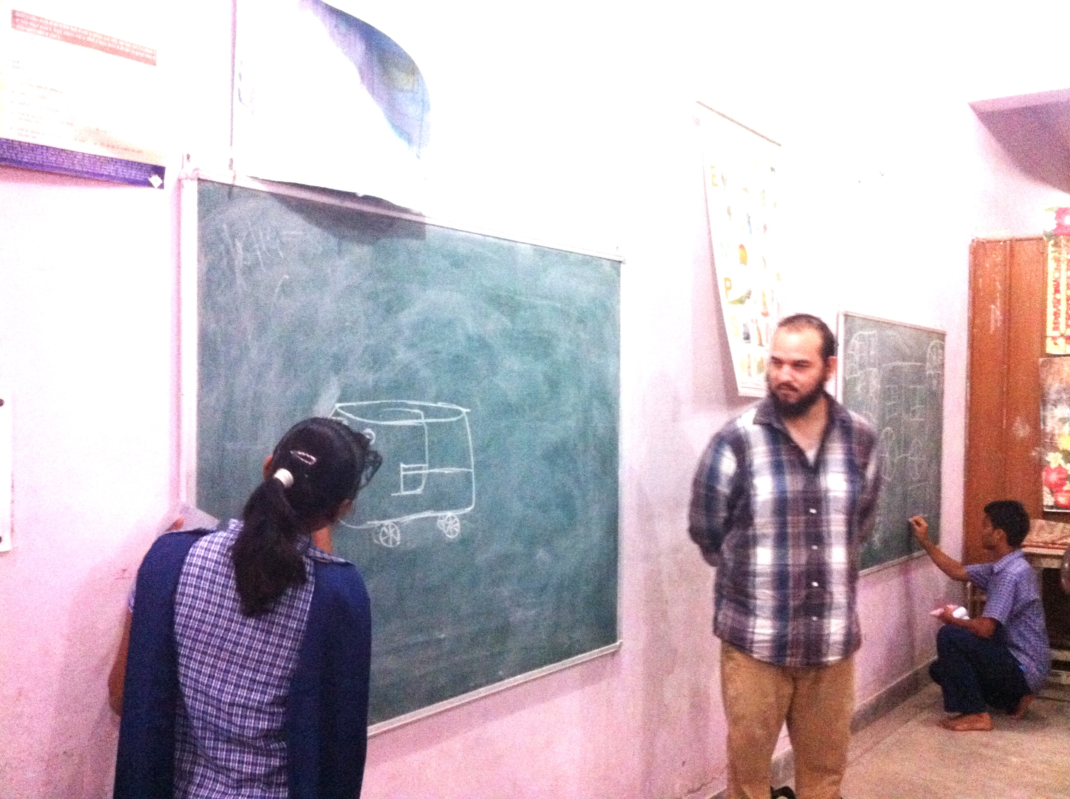
Sean leads an activity with the students, which illustrates the biblical theme of productivity.
The second sustainability factor was that we were able to bind a final copy for the NGO. We are looking to make this a sustainable component to the curriculum within the school. We look forward to a future relationship with the organization, as we look to interact further with community, over the course of our time with MATUL.

Bibliography

Bhagat, C. (2012). What young India wants. Delhi, India: Rupa Publications.
Greer, P. & Smith P. (2009). The poor will be glad: Joining the revolution to lift the world out of poverty. Grand Rapids, Michigan: Zondervan.
Grigg, V. (2010). Conversations on kingdom economics. Newton, Auckland: Urban Leadership Foundation.
Kagawa, T. (1936). Brotherhood economics. New York, United States: Harper & Brothers.
Mission to the Unreached. <http://mtuthomas.com/mtu/>
Schreiner, M. (2008). A simple poverty scorecard for India (1-54). `

